**Popeyes Management App**

IS 436-03 Structured Systems Analysis and Design Project

Deliverable 2: Requirements Definition and Use Case Analysis



Group Members:

Jessica Park

Farah Siddiqui

Betelhem Taddele

Danny Nguyen

Jatin Chauhan

Munam Ghazanfar

Ninh Ngo

Adil Mufti

03/28/2019

Table of Contents

Section 2: Requirements Definition & Use Case Analysis ………………... 3

Requirements Definition ………………………………………………… 4

Use Cases………..…………………………………………….……… 12

**Requirements Definition**

Functional Requirements:

Process-Oriented:

1. System must be able to store a large amount of data in a database
2. Must have the ability to upload photos
3. Must be able to create a checklist system such as to-do checklist or rush-readiness checklist
4. Communication must be available to other users within the app
5. System must be able to create critical reports and have the ability to show a summary report
6. Must be able to set reminders for users when jobs are not completed

Information-Oriented:

1. Must be able to store financial information such as sales, labor percentage periodic and photos of products
2. Store times and number of cars per interval that use the drive-thru
3. The system must store all information for a minimum of 3 years.

Non-functional Requirements:

Operational:

1. The system will be able to run on both android and apple devices
2. Should be able to integrate with the existing inventory system as well as the finance recording system
3. Should be able to backup all files to a secondary drive or cloud storage

Performance:

1. The system should have at least 500 Gb of memory storage and respond to system owner requests in an efficient manner, depending on the depth of the function.
2. The system should be available during all hours of a routine work day; costs can be saved by turning off the system during certain hours (0000 - 0800).
3. The system should support up to 10 users at a time doing various tasks, with scalability in mine for future use.
4. The network bandwidth should be rated for 1 Gbps.

Security:

1. All login and passwords that are sent through the network should be encrypted when stored.
2. System should include all available safeguards from viruses, worms, Trojan horses, etc.
3. The backups should be stored in 2 locations, on the cloud for quick access and within a locked storage area.
4. No users shall be created for employees that are non-managers unless authorized by system owner.

Cultural/Political:

1. Managers shall only be able to view information about their own store.

Interview #1:

Name of Interviewee: Syed Abid Iqbal

Position of Interviewee: Owner

Date & Time of Interview: 3/23/2019

Name of Interviewer: Farah Siddiqui

Purpose of Interview:

* Understand the current process of their transition of information.
* Determine the requirements for the future system.
* Gain insight on what Mr. Iqbal wants to improve and what additional thoughts he had on our proposed system.

**Open Items:** Schedule an interview with Abdelilah Moustafeh regarding an owner’s perspective and what he would like to be improved.

**Detailed Notes:**

* Syed Iqbal is the owner of five different location of Popeyes. He is interested in creating web application that will give an opportunity to have all this financial information of his business in one platform.
* All the location they currently use the traditional excel, and paper form. All of the log they currently use are on paper which is kept in the office in folder. The business doesn't seem to be organized. He is looking to improve his business give his manager extra help by making things easier for them.
* The businesses currently has Sicom as their point of sale which is gives the manager the opportunity to monitor their number. However, there is no system for budgeting. Most of the conversion among managers is done via group chat.

**Summary of interview:**

Mr. Iqbal expressed his concern regarding:

* Lack of the ability to data on time.
* Gather information is very time consuming.
* When a manager misses a task such as not doing the HACCP log, it can cause risk to the consumer health.
* If Manager fail to report the accurate information on time it because him to lose money.

**List of Questions:**

**Q.** What is the current process you are using to share and the gather data?

**A.** All of our conversion and information is shared via group chat which is not efficient.

**Q.** How often do you face problem with your current system?

**A.** He stated,” I face many problems. Sometimes the managers do not send the number on time without asking them. Most of the time number are not accurate, or something is always missing”. He said it is very hard for him to find the data that they in conversation which can be very confusing and time consuming.

**Q.** What are the requirements for the future system?

**A.** Iqbal wants website or app which comprises all the needs of business. He wants a simple checklist form which are checked off by managers from all his different store. The checklist should include the HACCP log, Daily Food Excellence Audit, Rush-Readiness. If HACCP log checkbox is not checked it should trigger an email response. The manager should be able to upload numbers such sales, labor and speed of drive thru. Also, the manager should be able to upload pictures. Automated report of all the text and critical instance that occur in each restaurant.

**Q.** Do you want manager to share the sensitive information such as, credit card information?

**A.** No, he doesn't want his manager to send sensitive information such as credit card information. The number should be taken by the manager from POS system which does not distinguish any credit card information. The web application should ensure security of customer details especially financial details. The card number can be only be read at the Point of Sale system to maintain autonomy.

**Q.** What are privileges that managers will have or are they even allowed to make changes?

**A.** The manager should to be able share, upload, view and edit the data. However, the Admin should be only be able to create username and password. Admin should be able to view a summary report of all users to ensure that the assigned task has been completed.

**Q**. What are some of the benefits that do you anticipate for the managers as supported by the web application?

**A.** It should require the managers to be able to share, upload, view and edit the data. However, the application should give only the administrator rights to create usernames and passwords while generating a summary report of all users.

**Q.** How many user accounts do you need?

**A.** Every store has five managers, so at least 15 accounts.

**Q.** How long you want the data to be stored?

**A.** I will require the data for comparison to get a summary of how many customers we have and their purchasing patterns.

**Q.** Will the user require the training?

**A.** Yes, they will require basic training on how to use the system.

**Interview #2:**

Name of Interviewee: Melissa Howell

Position of Interviewee: Manager

Date & Time of Interview: 3/24/19

Name of Interviewer: Adil Mufti

**Purpose of Interview:**

* The day to day tasks that a manager deals with and what may be challenging.
* What functions and features would be convenient to have on the application from a managers point of view.
* The organization skills that are currently in place with documents and important files.

**Summary of Interview:**

Melissa mentioned how:

* it is a hassle for them to keep track of previous documents because it wasn’t paperless.
* communication between managers could be stronger because they currently use their smartphone in a group chat.
* ensuring that the staff is completing their tasks was stressful to handle so the use of the checklist will help ensure everyone is doing what they need to before they leave.

**Open Items**:

Schedule an interview with the store manager, Melissa Howell to find out how things are currently being kept up with as well as implementations that will helpful.

**Detailed Notes:**

* Melissa is the manager at the Essex location and works 40 hours a week. She spends most of her time taking care of tasks related to the business in the earlier part of her shifts, and then assists customers with her team.
* They use paper to create schedules and many of the other documents are kept in a binder which can easily be lost and it is harder to navigate throughout time.
* Paperwork can get lost as time goes by since everything is physically kept in a binder.

**List of Questions:**

**Q.** How long have you been working at Popeyes?

**A.** I started working at Popeyes as a part-time crew member four years ago and worked my way up to Store Manager within my second year.

**Q.** What is the most challenging task you have to deal with as a manager?

**A.** As a manager, I would say the most difficult task I partake in would have to be making sure crew members are on time and doing their job correctly. If they are doing what they’re supposed to then it allows me to focus on internal needs for the business much efficiently. Also, the ordering procedure for supplies is quite time consuming so a

**Q.** How do you keep track of schedules/ create schedules? Any difficulties?

**A.** Currently, schedules are made on paper and put into a binder which we keep in the backroom. It can be hassle when that binder builds up throughout time because if we needed to go back and see who worked on a particular day it requires me to manually look through hundreds of sheets.

**Q.** How many staff members do you have? Is this amount consistent?

**A.** Our location consists of 20-30 employees with 7-8 employees per shift. During slow hours we try to limit the amount of employees hired due to the slow business.

**Q.** What type of organization method do you use for orders, budgets, inspections?

**A.** All documents regarding important information of the business is kept in a binder just like what we have for the schedules. When the owner comes and visits our location that is one of the major things he checks and it is also a necessity for us to have in case of any emergencies.

**Q.** As a manager, what sort of features would be helpful in an application for you?

**A.** Since most of our documents are on paper it would be relatively convenient for us to have documents that are paperless. This saves time for me looking through a binder. Another feature that would be great would be a way for manager to easily get in touch with other managers in the district.

**Q.** How often would you have to work at other Popeyes location?

**A.** For the most part, I stay at the location I was hired at but there are times when a manager calls out at another location and coverage is needed (especially weekends).

Observations:

This restaurant Popeyes is located at Essex, MD. This Popeyes location has lobby for 45 people. When entering the restaurant, the customers’ first interaction is with the cashier. There is an office located on the right side of the restaurant which includes a set up for important documents and folders and all the incoming mails and invoices are stored in there as well. The daily operation includes doing HACCP logs, rush readiness checklist and Daily Food Excellence Audit. The staff records all of these activities in the red book. Red book is a manager’s book which tracks and analyze daily operations anytime and anywhere and creates tasks as managers do their walk-throughs. On the left side of the drive-thru window, there is a monitor which records the speed of the drive-thru. Most of the communication among the management team is done via iMessage group.

Questionnaire**:**

1. On a scale of 1 to 10, kindly rate how group chat has been useful to you.

Decreasing ← 1,2,3,4,5,6,7,8,9,10 →Increasing

2. Since now you use group chat for information sharing, how likely are you to recommend it to other managers?

1.not likely

2. Less likely

3. Likely

4. Somehow likely

5. Highly likely

3. How good can a website application solve the current problem

A. N/A Poor

B. Good

C. Very Good

D. Excellent

4. A good website application protects consumer details. Kindly agree or disagree.

1. Strongly disagree

2. Slightly Disagree

3. Disagree

4. Agree

5. Slightly Agree

6. Strongly Agree

5. Pick how many user accounts the web application should support

1. *Less than 5*

2. *Between 6 and 10*

3. *Between 11 and 15*

4. *More than 15*

6. How many months that the web application should store the information

1*. Less than 3 months*

2. *Up-to six months*

3*. Up-to nine months*

4. *Up-to 12 months.*

7.How well are the staff able to use the application without training?

A. N/A Poor

B. Good

C. Very Good.

D. Excellent

Document Analysis:

A website application for Popeyes Restaurant requires identification of user requirements, functionalities and features that should be incorporated as per the survey done on the site. After an interview with the manager, it was determined that the food chain owns five food stores and each store is under the similar chain of management. This suggests that the application will be used by all store managers who shall use the platform to send daily reports to a centralized management.

The general manager offered information regarding the requirements of the website application. As a result, literature analysis will be conducted to understand how to incorporate the user requirements in a web application for efficient management. In addition, literature regarding all the financial of store details shall be analyzed to ensure that security is at maximum.

Use Cases:

|  |  |  |
| --- | --- | --- |
| **Use Case Name:** Create Account | **ID:** 1 | **Priority:** High |
| **Actor**: Manager, Owner | | |
| **Description**: Allows manager or owner to create an account with a username and password | | |
| **Trigger:** Owner or a manager interacts with the system for the first time. A new manager is hired  **Trigger Type**: External | | |
| **Preconditions:** User’s first time interacting with the system and does not have an account yet | | |
| **Normal Course:** User creates unique username and password to be used to validate credentials every time the user logs in to the system | | |
| **Postconditions:** User will have a username and password that they need to enter each time they want to log in | | |
| **Exceptions:** E1: Username is unavailable   1. System prompts user to select a different username   E2: Password is too weak   1. System prompts user to select a stronger password | | |

|  |  |  |
| --- | --- | --- |
| **Use Case Name:** Log-in | **ID:** 2 | **Priority:** High |
| **Actor**: Manager, Owner | | |
| **Description**: Manager or owner needs to enter credentials to access system | | |
| **Trigger:** User needs to interact with a feature/function of the system  **Trigger Type**: External | | |
| **Preconditions:** User has previously created an account | | |
| **Normal Course:** User enters the same unique username and password that they previously used to create his or her account | | |
| **Postconditions:** System validates user and user is able to access the system’s remaining features | | |
| **Exceptions:** E1: Invalid credentials   1. User will not be able to access system   E2: Former manager  1. User will not be able to access system | | |

|  |  |  |
| --- | --- | --- |
| **Use Case Name:** Input Financial Information | **ID:** 3 | **Priority:** High |
| **Actor**: Manager, Owner | | |
| **Description**: Allows user to add the financial information sales, labor percentage periodic | | |
| **Trigger:** Manager needs to record financial numbers  **Trigger Type**: External | | |
| **Preconditions:** User is logged in to the system | | |
| **Normal Course:** User enters financial information sales, labor percentage periodic to be stored in system and viewed by owner | | |
| **Postconditions:** Information sales and labor percentage periodic are stored | | |
| **Exceptions:** E1: Invalid input (symbols, letters)   1. System prompts user to enter number values | | |

|  |  |  |
| --- | --- | --- |
| **Use Case Name:** Upload Photo | **ID:** 4 | **Priority:** Medium |
| **Actor**: Manager, Owner | | |
| **Description**: Allows user to upload image of a product or area in a restaurant | | |
| **Trigger:** User needs to provide a visual representation of an incident or product that needs to be reported to the owner  **Trigger Type**: External | | |
| **Preconditions:** 1. User is logged in to the system  2. User has taken the photo | | |
| **Normal Course:** User uploads photo from their device to the system and provides a brief description | | |
| **Postconditions:** The desired photo is uploaded and can be seen by owner | | |
| **Exceptions:** E1: User attempts to upload an incompatible file type   1. System prompts user to upload a file that is supported (png, gif, etc.) | | |

|  |  |  |
| --- | --- | --- |
| **Use Case Name:** Create to-do checklist | **ID:** 5 | **Priority:** Medium |
| **Actor**: Manager, Owner | | |
| **Description**: Allows user to create and access checklist to complete and manage separate tasks | | |
| **Trigger:** User needs to have a visual representation of his or her incomplete and completed tasks for the day/work period  **Trigger Type**: External | | |
| **Preconditions:** 1. User is logged in to the system  2. User has taken the photo | | |
| **Normal Course:** User enters input for each task that are then put into a to-do list | | |
| **Postconditions:** System displays a checklist containing separate tasks that the user can mark under “to-do” or “completed” | | |
| **Exceptions:** No exceptions | | |

|  |  |  |
| --- | --- | --- |
| **Use Case Name:** Message other managers | **ID:** 6 | **Priority:** High |
| **Actor**: Manager, Owner | | |
| **Description**: Allows users to communicate with other managers using the system in order to complete a certain tasks | | |
| **Trigger:** A task was incomplete or done incorrectly, or a new task comes up that needs to be completed  **Trigger Type**: External | | |
| **Preconditions:** User is logged in to the system | | |
| **Normal Course:** User inputs a message that can be sent to another user of his or her choice | | |
| **Postconditions:** Other manager(s) receive notification that displays the message. Sender receives an alert to confirm message was sent | | |
| **Exceptions:** E1: No internet connection   1. System alerts user that an internet connection is required and that message failed to send | | |

|  |  |  |
| --- | --- | --- |
| **Use Case Name:** Store and Display Drive-thru Data | **ID:** 7 | **Priority:** Medium |
| **Actor**: Manager, Owner | | |
| **Description**: Allows users to enter times and number of cars per interval that go through the drive-thru | | |
| **Trigger:** Company wants to collect data on drive-thru efficiency  **Trigger Type**: External | | |
| **Preconditions:** 1. User is logged in to the system  2. Drive-thru data has already been recorded by separate  system | | |
| **Normal Course:** User inputs data into system that was recorded from the other system that collects drive-thru data | | |
| **Postconditions:** Displays drive-thru data separated by time intervals and days | | |
| **Exceptions:** No exceptions | | |

|  |  |  |
| --- | --- | --- |
| **Use Case Name:** Create Critical Reports | **ID:** 8 | **Priority:** High |
| **Actor**: Manager, Owner | | |
| **Description**: Allows creation of reports on all the text and critical instances that occur in each restaurant | | |
| **Trigger:** An incident occurs in a restaurant that requires immediate notification to other managers or to the owner  **Trigger Type**: External | | |
| **Preconditions:** User is logged in to the system | | |
| **Normal Course:** User writes report in system that will be sent to desired recipient | | |
| **Postconditions:** Critical report displayed and recipient(s) can access its contents | | |
| **Exceptions:** No exceptions | | |

|  |  |  |
| --- | --- | --- |
| **Use Case Name:** Display Summary Reports | **ID:** 9 | **Priority:** High |
| **Actor**: Manager, Owner | | |
| **Description**: Allows owner to view summary report of other users’ entered data and completed assigned tasks | | |
| **Trigger:** Owner needs to view managers’ progress and reports  **Trigger Type**: External | | |
| **Preconditions:** 1. Owner is logged in to the system  2. Managers have uploaded financial numbers, photos,  and reports | | |
| **Normal Course:** Owner selects “summary report” to view summary of all information entered for the day | | |
| **Postconditions:** Summary report displayed showing all of the other managers’ activities and inputs into the system | | |
| **Exceptions:** No exceptions | | |

Use Case Diagram:

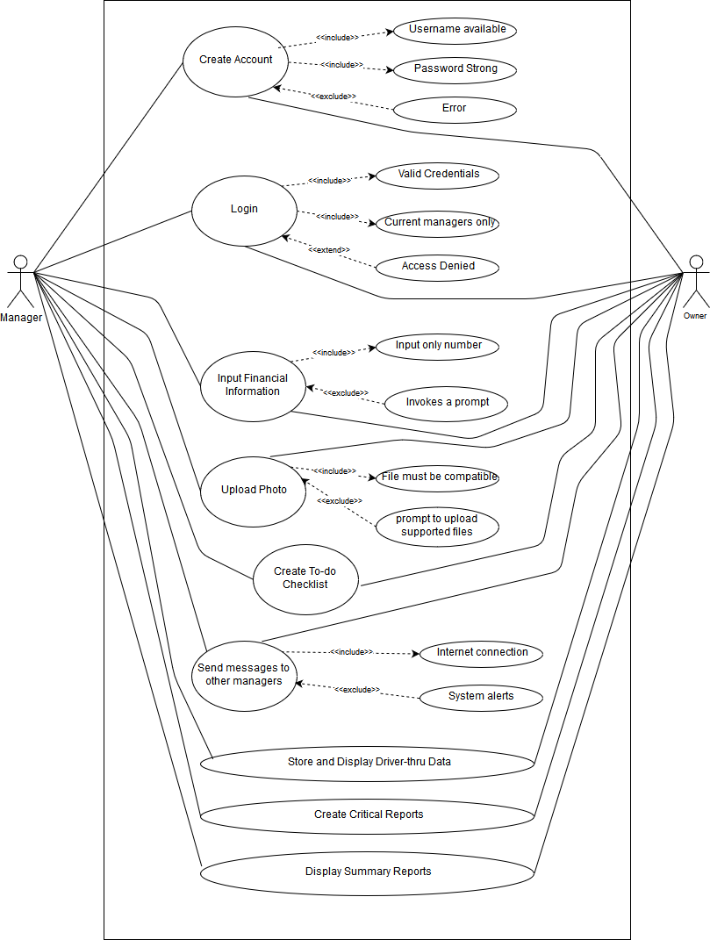

Popeyes Management App